Dog Shampoo Comparison Chart
Drs. Foster & Smith Educational Staff
Shampoo | Tear-  less | Contains Condi-  tioning Agents | For Itching Skin | For Oily Skin | For Skin Infec-  tions | For Persis-  tent Coat Odors | Kills Fleas & Ticks | No Added Frag-  rance | No Dyes
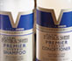
Premier System® Shampoo
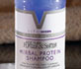
Herbal Protein Shampoo
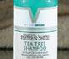
Tea Tree Shampoo
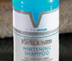
Brightening Shampoo
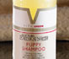
Puppy Shampoo
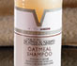
Oatmeal Shampoo
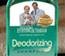
Deodorizing Shampoo
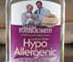
Hypo Allergenic Shampoo
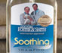
Soothing Shampoo
Shampoo | Tear-  less | Contains Condi-  tioning Agents | For Itching Skin | For Oily Skin | For Skin Infec-  tions | For Persis-  tent Coat Odors | Kills Fleas & Ticks | No Added Frag-  rance | No Dyes
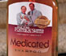
Medicated Shampoo
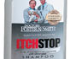
Itch Stop Shampoo
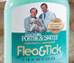
Flea & Tick Shampoo
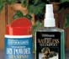
Waterless Shampoo Spray
Waterless Shampoo Powder
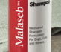
Malaseb Shampoo
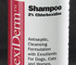
Chlorhexiderm Shampoo
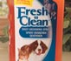
Fresh 'N Clean Grooming Spray
Shampoo | Tear-  less | Contains Condi-  tioning Agents | For Itching Skin | For Oily Skin | For Skin Infec-  tions | For Persis-  tent Coat Odors | Kills Fleas & Ticks | No Added Frag-  rance | No Dyes

